**Title Font Size Should Be 16. Length Maximum Eighteen Words**

Author1

Affiliation Department, Institution, City, Country

[author@institution.ca](mailto:author@institution.ca)

Author

Affiliation Department, Institution, City, Country

[author@institution.co.uk](mailto:author@institution.co.uka)

Author

Affiliation Department, Institution, City, Country

[author@institution.com](mailto:author@institution.com)

Received: xx/xx/xxxx

Accepted: xx/xx/xxxx

Online Published: xx/xx/xxxx

**Abstract**

The abstract should be no more than 250 words. Please include the aim of the research, the procedure and methodology used, key findings, and the conclusion. Be sure to highlight the novelty of the research. While practical implications or recommendations are optional, you may include them if relevant. Remember to double-check your spelling.

**Keywords:** Word 1, Word 2, Word 3, (minimum 3 and maximum 5 words).

**JEL Classification:**

**Introduction**

Provide brief introduction to the topic. The in-text citation should be given properly (Smith, 2024). If you add direct quote, please provide page number. For instance, “it is essential to differentiate between knowledge hiding and knowledge hoarding because these are two distinctive concepts” (Haque, 1014, p. 446).

You may start the sentence with citations. According to Rehman et al. (2022), “the main problem is the uncertainty of the results in adopting Industry 4.0 and its potential effect on the work lives of individuals. Also, the associated uncertainties can differ between developed and developing countries" (p. 228).

Include the scope and significance of the study, followed by aim of the research.

If you include any sub-heading, it should be in italic.

**Literature Review**

Introduce the research variables. Ensure you have a proper critical discussion about the variables of research. Identify and state the gap in the literature before proposing hypotheses. For instance, leadership dark tendencies have been discussed but it has not been studied how these dark tendencies impact the social capital of the organization. Hence, we propose:

H1: *Leadership dark tendencies significantly negatively impact the social capital of the organization.*

Your literature review shall be minimum 1000 words. Any claim or statement made must be backed by the in-text citation. For instance, male under stress often demonstrate physical and behavioral symptoms (Haque & Aston, 2016). However, there is limited evidence that age has a role in determining the relationship between occupational stress and organizational commitment. In other words, the mediating effect of age has been understudied. Therefore, we propose:

H2: *Age significantly mediates the relationship between occupational stress and organizational commitment of employees.*

You can include any theoretical framework in the literature section. Kindly note that any table or figure used in the sections must be captioned and mentioned at least once in the manuscript. If you include any table, the caption should be at the top.

**Table 1:** Summary of theories and models of Stress

|  |  |  |
| --- | --- | --- |
| **Theories and Models** | **Key Concepts** | **Reference** |
| Person-and-Environment Fit | Stress arises due to interaction between person and environment finding no perfect fit. | (French et al., 1982) |
| The DRIVE Model | Stress transacts due to various factors including demand, resources, and individual efforts being not aligned | (Mark & Smith, 2008) |

Source: author’s illustration

As evident in Table 1, stress results from various factors. Similarly, if you propose a theoretical framework. It should be captioned beneath while at least mentioned once in the main body. For instance, theoretical framework was developed (Figure 1).

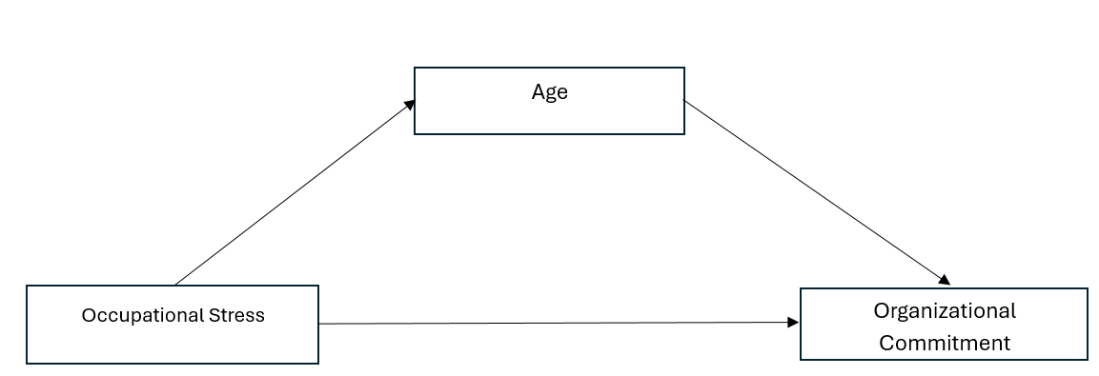

**Figure 1:** *Theoretical framework (author’s own illustration)*

**Research Methodology**

Please provide proper details about your data collection process. It should include your research instruments, research design, sample size, and sampling technique. You must provide proper justification for preferring your methodological stance and selection of the case study. For instance, the sample size is 100 so provide justification for how it is acceptable. For example, according to Roscoe (1975) a rule-of-thumb for sample size is that sample size over 30 and below 500 is acceptable in social science. You must include how you ensure that data is reliable and valid. Provide details of ethical considerations.

*Ethical considerations*

The above italic heading is to give you an idea about sub-heading in the section. There is no limit of sub-headings in any section.

**Findings and Discussions**

Provide details of the results and findings. You can include tables to show reliability, validity, demographic variables, testing hypotheses, and so on. For instance, demographic details of the present study (Table 2).

**Table 2**: Gender Representation

|  |  |  |
| --- | --- | --- |
| **Gender** | **Frequency** | **Percentage** |
| Male | 97 | 51.2% |
| Female | 82 | 43.6% |
| Other | 9 | 4.7% |
| Total | 188 | 100% |

Source: *Research participants in this study*

If you include any figure, it should be properly discussed (Figure 2).

**Figure 2:** *Gender Representation in study.*

Below are some of the other examples of tables used in the study. See below:

*Measurement of Model Validity*

Using PLS(SEM) we attained discriminant and convergent validity, which are indicators of measurement model validity. The construct validity is reflected through Cronbach’s alpha (α), composite reliability (CR), and average variance extracted (AVE). Cronbach’s alpha (α) all the items of the construction are acceptable because value is above 0.7 (Kaur et al., 2024), which is a threshold value (Table 3). Similarly, CR for all items is above 0.7 (benchmark value), while AVE is above 0.5 (Table 3). In other words, the key indicators for all constructions are reliable and valid.

**Table 3:** Finding of the measurement model (first order, reflective)

|  |  |  |  |
| --- | --- | --- | --- |
| Construct | Cronbach’s Alpha (α) | Composite Reliability (CR) | AVE |
| Occupational Stress | 0.90 | 0.92 | 0.72 |
| Age | 0.88 | 0.90 | 0.64 |
| Organizational Commitment | 0.92 | 0.94 | 0.81 |

Source: Results obtained from PLS-SEM

You must ensure that your results should be supporting or contradicting existing literature. Provide proper in-text citations. If your findings are unique, ensure you do mention that the findings are novel. For instance, our findings support the earlier work of Haque et al., (2018) or our findings partially oppose the previous empirical studies (Haque & Aston, 2016; Rahman et al., 2022). Hence, we reject hypothesis 1 or we fail to reject hypothesis 2 (Table 4).

**Table 4:** Hypotheses Testing (Direct Relationship)

|  |  |  |  |  |  |
| --- | --- | --- | --- | --- | --- |
| Hypotheses | Β | Standard Deviation | *t*-value | P-value | Decision |
| H1: Occupational Stress → Organizational Commitment | 0.78 | 0.11 | 3.03 | 0.000 | Fail to Reject |
| H2: Age → Organizational Commitment | 0.58 | 0.09 | 5.12 | 0.000 | Reject |

*Note: ***p<0.1, **p<0.05,* ns= non-significant (p>.05) *(Two Tail)*

You can have more than one table. For instance, to check mediating effects (or indirect effect). See the table below.

**Table 5:** Hypotheses Testing (Mediating Relationship)

|  |  |  |  |  |  |
| --- | --- | --- | --- | --- | --- |
| Hypotheses | Indirect Effect | Standard Deviation | *t*-value | P-value | Decision |
| H3: Age mediates Occupational Stress and → Organizational Commitment | -0.18 | 0.06 | 2.51 | 0.001 | Fail to Reject |

*Note: ***p<0.1, **p<0.05,* ns= non-significant (p>.05) *(Two Tail)*

**Conclusion and Recommendations**

Provide conclusion about the findings. It should be a minimum of 300 words. You should also include research limitations, future directions and practical implications for future studies. Kindly do not include any in-text citations in the conclusion section.

Your paper should not be less than 3,000 words (excluding references). Maximum words should not exceed 8,000 (excluding references). Double check that you only add references that are mentioned in the manuscript. Reference list should be in alphabetical order.

Below is the style of references.

# References

Akhter, T., & Haque, A.U. (2023). On the Prospects of Sustainable Tourism in Bangladesh. In: Yamoah, F.A., Haque, A.U. (eds). *Corporate Management Ecosystem in Emerging Economies.* Palgrave Macmillan, Cham. <https://doi.org/10.1007/978-3-031-41578-4_10>

Fred A. Yamoah & Haque, A.U. (Ed.). (2023). *Corporate Management Ecosystem in emerging economies: Global Perspective.* Palgrave McMillian, UK.

Haque, A. U. (2024). Knowledge hiding and occupational stress affecting employees’ performance: comparative analysis from emerging and advanced economies, *Knowledge Management Research & Practice*, 22(5), 446–459. <https://doi.org/10.1080/14778238.2024.2322463>

Haque, A.U., & Aston, J. (2016). A Relationship between Occupational Stress and Organizational Commitment of I.T Sector's Employees in Contrasting Economies. *Polish Journal of Management Studies,* 14(1), 95-105.

Pham, F. (2024). *Workplace Stress: Causes, Impacts And Solutions.* Forbes. Retrieved from: <https://www.forbes.com/councils/forbesbusinesscouncil/2024/09/17/workplace-stress-causes-impacts-and-solutions/#:~:text=The%20Impact%20Of%20Workplace%20Stress&text=Over%20time%2C%20workplace%20stressors%20can,risk%20of%20mental%20health%20problems>.

Rahman, M., Kamal, M. M., Aydin, E., & Haque, A. U. (2020). Impact of Industry 4.0 drivers on the performance of the service sector: comparative study of cargo logistic firms in developed and developing regions. *Production Planning & Control,* 33(2–3), 228–243. <https://doi.org/10.1080/09537287.2020.1810758>

Roscoe, J. T. (1975). *Fundamental Research Statistics for the Behavioral Science, International Series in Decision Process*, 2nd Edition, New York: Holt, Rinehart and Winston, Inc.